Q1.

//wap print even and odd number in given range

//start =10 end=25

//o/p:odd:11 13 15...

//start=1 end =15

//o/p :even : 2 4 6 8

#include<stdio.h>

void main(){

int start,end;

printf("For odd:\n");

printf("\nEnter start :");

scanf("%d",&start);

printf("\nEnter end :");

scanf("%d",&end);

printf("Odd:");

while(start<=end){

if(start%2!=0){

printf("%d\t",start);

}

start++;

}

///////////////////////////////

printf("\nFor even\n");

int s,e;

printf("Enter start :");

scanf("%d",&s);

printf("\nEnter end :");

scanf("%d",&e);

printf("Even:");

while(s<=e){

if(s%2==0){

printf("%d\t",s);

}

s++;

}

}

Op

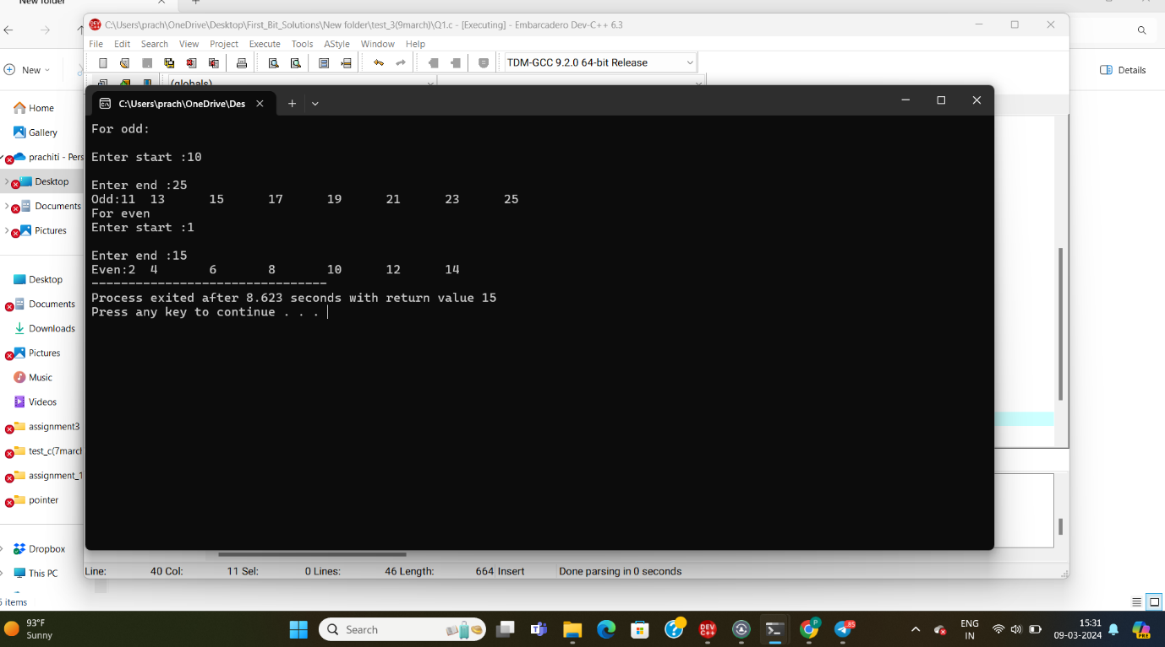

Q2

#include<stdio.h>

void main(){

int start,end;

printf("\nEnter start :");

scanf("%d",&start);

printf("\nEnter end :");

scanf("%d",&end);

int sum=0;

while(start<=end){

sum=sum+start;

start=start+2;

}

printf("sum :%d",sum);

}

Op

